Week 5 – E-Commerce System
Internship: Developers Arena
E-Commerce System

Week 2 Assignment
Programming Language: Java
IDE: Eclipse IDE

Submitted By:

1. Project Overview
Project Description
The E-Commerce System is a console-based Java application developed to simulate basic online shopping operations. The application allows users to browse products, add products to a shopping cart, update quantities, remove products, calculate totals, place orders, and view previous orders.
The project is designed to demonstrate practical Object-Oriented Programming concepts such as abstraction, inheritance, polymorphism, encapsulation, method overriding, and HAS-A relationships.
Project Objectives
- Develop a functional console-based E-Commerce application using Java.
- Implement different product types using an abstract Product class.
- Apply inheritance and polymorphism through product subclasses.
- Manage shopping cart items and quantities.
- Calculate product discounts and cart totals.
- Process orders and calculate 18% GST.
- Generate unique order IDs.

2. Setup Instructions
Requirements
- Java Development Kit (JDK)
- Eclipse IDE
- Java project with the required source packages
Installation and Configuration
- Install and configure the Java JDK.
- Open Eclipse IDE.
- Create or import the E-Commerce System project.
- Verify that all classes are present in their respective packages.
- Ensure that ECommerceSystem.java is available as the main class.
- Run ECommerceSystem.java using Run As → Java Application.
- Use the console menu to interact with the application.

3. Code Structure
src

├── products
│ ├── Product.java
│ ├── ElectronicsProduct.java
│ ├── ClothingProduct.java
│ └── BookProduct.java
│
├── cart
│ ├── CartItem.java
│ └── ShoppingCart.java
│
├── orders
│ ├── Order.java
│ └── OrderManager.java
│
└── ECommerceSystem.java

Class | Responsibility
Product | Abstract base class containing common product information and behavior
ElectronicsProduct | Represents electronic products and calculates their discount
ClothingProduct | Represents clothing products and calculates their discount
BookProduct | Represents book products and calculates their discount
CartItem | Stores a product and its quantity
ShoppingCart | Adds, removes, updates cart items and calculates the cart total
Order | Creates an order and calculates GST and final amount
OrderManager | Manages and displays multiple orders
ECommerceSystem | Main class that connects all components and handles user interaction

4. Visual Documentation
- Browse Products
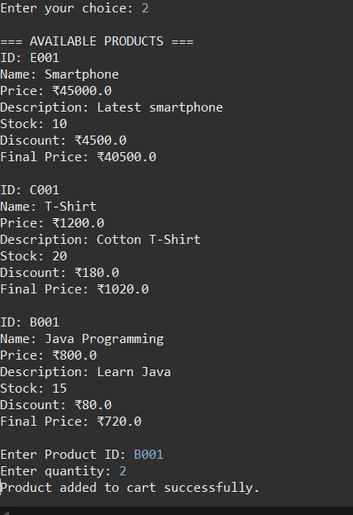

- View Cart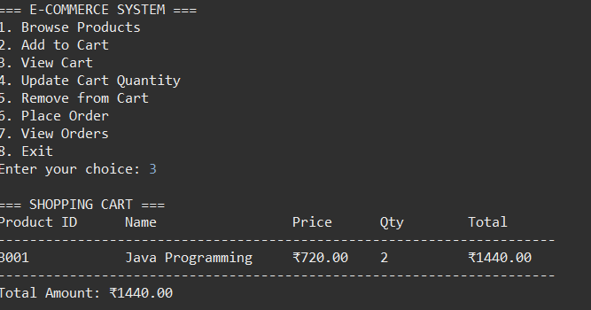
- Order Details
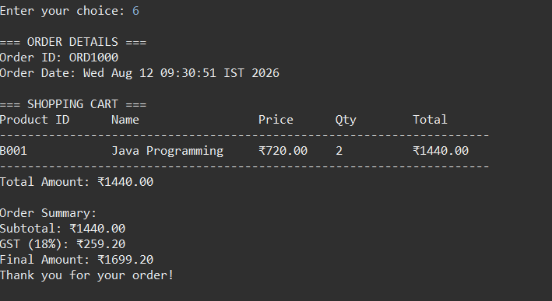

5. Technical Details
5.1 Programming Language and Technologies
- Programming Language: Java
- IDE: Eclipse IDE
- Data Structures: ArrayList, List
- Application Type: Console-based application
- Concepts: OOP, Abstraction, Inheritance, Polymorphism, Encapsulation, HAS-A Relationship

5.2 Data Structures
ArrayList
ArrayList is used to store collections of objects dynamically.
It is used for:
- Available products
- Shopping cart items
5.3 Algorithms and Application Logic
Product Search
The application searches for a product by comparing the entered Product ID with the IDs stored in the product list.
Read Product ID
↓
Search Product List
↓
Compare Product IDs
↓
Match Found?
/ \
Yes No
↓ ↓
Return Product
Product Not Found
Add Product to Cart
When a product is added:
- The cart checks whether the product already exists.
- If it exists, its quantity is increased.

6. Testing Evidence
The application was tested using different functional scenarios.
Test Case | Action | Expected Result | Status
TC01 | Browse products | Available products are displayed | Pass
TC02 | Add product | Product is added to cart | Pass
TC03 | Add same product again | Existing quantity increases | Pass
TC04 | View cart | Cart details and total are displayed | Pass
TC05 | Update quantity | Product quantity is updated | Pass
TC06 | Remove product | Product is removed from cart | Pass
TC07 | Calculate total | Correct cart total is displayed | Pass
TC08 | Place order | New order is created | Pass
TC09 | Calculate GST | 18% GST is calculated | Pass
TC10 | Generate order ID | Unique sequential order ID is generated | Pass
TC11 | View orders | Previous orders are displayed | Pass
TC12 | Complete application flow | All menu operations work successfully

